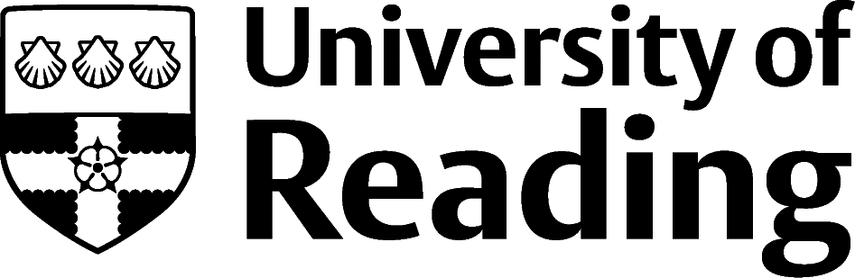
Admissions Office

Unit name goes here

POSTGRADUATE
Applicant cancellation
form

Please complete and return this form only if you wish
to cancel your agreement with the University.

Please note, this form can only be used if you are cancelling within 14 days after the day on which you accepted your offer of a place. Please either post or email your completed form using the details below. If sending by email, please ensure you send your cancellation request from the email address used in your application form.

To: The Director of Admissions and Global Recruitment

Address: Miller Building, the University of Reading, PO Box 217, Reading. RG6 6AH

Email: pgadmissions@reading.ac.uk

I hereby give notice that I cancel my agreement with the University of Reading and no longer want to accept my offer of a place.
Name of applicant | Click here to enter text.
Applicant ID (provided on your offer letter) | Click here to enter text.
Date offer received | Click here to enter text.
Signature of applicant (if by post)
Date | Click here to enter text.

