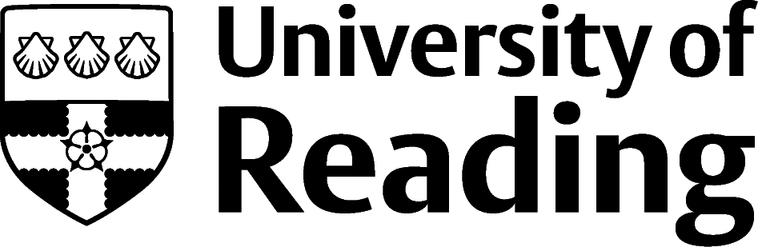

Arts committee grant application

Introduction
The Arts Committee, or Standing Committee of Senate on the Arts, is a large committee representing the wide artistic interests of the University and local community. The Committee is made up of both student representatives and staff, including representatives from key RUSU societies.

The Arts Committee receives an allocation of £10,000 each year from central funds and offers grants for Arts initiatives across the University, in response to applications from staff and students. This amount is distributed across three meetings (one per term). There is no upper or lower limit on the amount that can be requested. Typical grants are for amounts between £100- £1,000.

How to apply and where to find help
You will need to fill out the short application form, giving details of your proposed initiative and a fully costed budget. Account information is also requested in order that the grant can be paid in a timely manner, should your bid be successful.

Your completed application should be submitted to the Secretary to the Arts Committee, Rachel Goodwin, via email to r.goodwin2@reading.ac.uk by the deadlines given below.

If you are planning to hold an event as part of your initiative, you can find advice and information on holding an event at the University here: http://www.reading.ac.uk/internal/events-guide/evtg-index.aspx

Members of the Arts Committee are always willing support the development of applications, particularly from those who are not Arts professionals. Please contact the Secretary who will put you in touch with a suitable committee member.

Criteria
In making decisions about which applications to support, the Committee typically takes into account the following issues. Please bear these in mind when completing your application:

- How widely is the event/activity likely to be accessed by members of the University community? Is it something that is likely to be restricted to a specific academic department, or to students from a specific degree programme?
- Is the event/activity likely to be accessed by, or to involve the participation of, members of the public outside of the University?
- Does the event/activity serve to raise the profile of the arts at Reading, or to foster closer co-operation between arts organisations on and off campus?
- Does the event/activity promote student involvement in the arts (e.g. allowing students to participate in cultural activities unrelated to their academic programmes of study)?
- Does the event/activity offer good value for money (e.g. reaching a potentially wide audience, or making a significant cultural impact, for the amount of funding being requested)?
- Would the event/activity be able to take place without Art Committee funding?
- Have alternative sources of funding been sought?

The Committee does not usually fund events or activities which:

- Are being undertaken specifically as part of a student’s academic degree programme, and which would normally be funded within an academic department;
- Do not involve any direct association with a member of the University community.

Budget
- The Committee does on occasion agree to provide partial funding (i.e. less than the full amount being requested in the application).
- The Committee tends not to provide funding for subsistence costs, or towards the costs of alcoholic drinks.
- Before applying, please ensure that the timeframe for the event is realistic and that, where necessary, initial discussions have been held with potential venues to confirm costs and availability.
- Please note that the Committee will not provide funding for the payment of fees to existing staff or students (including PhDs).
- Where possible, applicants are advised to seek a quote for printing costs before submitting the application. Further information is available at: http://www.reading.ac.uk/dps/
- Please note that the Committee will be awarding its budget for 23/24 and therefore all funds considered would need to be incurred prior to the end of the financial year (31 July 2024). Should this not be the case, please highlight this within your application and you may be advised to apply for any further funds at a future round.
Timescales
The Arts Committee meets three times a year to consider applications. Applications may be submitted to the Secretary at any time and will be reviewed at the next available meeting.

The meeting dates and application deadlines for Academic Year 2023/24 are:

Deadline for Applications | Arts Committee meeting
Wednesday 25 October 2023 at 5pm | Thursday 9 November 2023
Wednesday 24 January 2024 at 5pm | Thursday 8 February 2024
Wednesday 24 April 2024 at 5pm | Thursday 9 May 2024

Award Requirements
If your application is successful, the award will be paid as soon as possible after account details are provided. Other methods of payment are available in certain circumstances.

In order to meet audit needs, the Committee requires that a brief report, of no more than 500 words, be submitted at the completion of the initiative to evaluate its success.

We would also be grateful if successful applicants could provide a brief news story/blog post, which can be used on the University website to highlight the breadth of arts activities hosted and supported by the University.

The Arts Committee would welcome recognition of its support via use of its logo (available on request) or written acknowledgement in promotional materials.

