Evaluation
  - Process document (June 2023)
Table of Contents
The evaluation structure 2
1. Overview of the top level numbers 2
2. Analysis: Have the strategic objectives been met? 3
3. Analysis: Did we meet the content requirements? Are the learners happy? 3
4. Refinement 4
The evaluation process 4

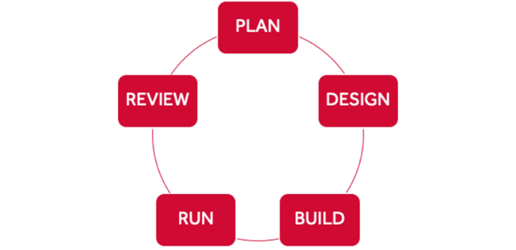
This document details the processes and templates involved in the evaluation of Short created by the University of Reading (UoR) and hosted on the FutureLearn platform. Evaluation is part of the project process for each course as we explain in the Course Build Workshop.

The evaluation document is an internal record of the review undertaken for each course 6 months after launch and the changes suggested as a result, as well as a document to be shared internally to demonstrate the continuous development of our courses and the alignment of these changes with the Short Online Courses strategic framework.
In advance of completing a course evaluation, please liase with the Digital Learning Producer who originally produced the course. The Digital Learning Producer will brief you on anything significant from the development and production stages and discuss any key issues which may inform the evaluation process.

The evaluation structure
Each evaluation should follow this basic structure which allows for different measurements to be applied depending on the original objectives of the course. The final evaluation report should be uploaded to the evaluation folder in the respective course folder on Sharepoint and linked on the relevant card in the Teams Scheduler.
It can be applied to any course, and uses the scoping document as a way to structure the information included.
- Overview of the top level numbers
- Analysis: Have the strategic objectives been met
- Analysis: Did we meet the content requirements – are the learners happy
- Refinement suggestions

Overview of the top level numbers
Take the numbers from Looker:
- Enrolments
- Activated enrolments
- Percentage activated social enrolments
- Completion rate
- Positive feedback
Activated enrolments = enrolments that viewed at least 2 steps
Activated social enrolments = proportion of activated enrolments where a learner has posted at least one comment.
Completion rate = proportion of activated learners who have completed at least 90% of the course.
Positive feedback = proportion of those responding to the weekly sentiment survey with a smiley face.

Note: Include the dates – the launch date of the course and the date, 6 months or so later, when these numbers were downloaded. This is so comparisons with other courses or runs over similar amounts of time can be made if necessary.
Educators are always interested to know how these compare with other courses but it’s very difficult to make a sensible comparison as other courses may have different audiences, different lengths, have been running for longer, etc. If necessary, you can compare to our programme averages using the Partner Summary on Looker, selecting a similar time frame for the report as the course you’re evaluating and calculating the average by dividing by the number of courses.
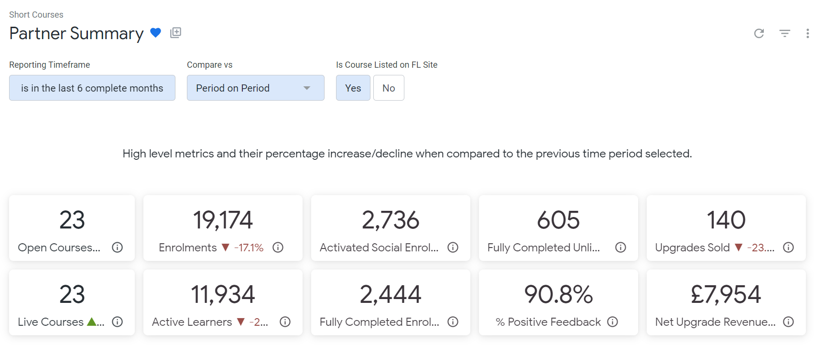
Note: you can’t look at open and private courses together – select one or the other (Is course listed on FL site – yes or no).
If there’s a suitable course to compare with, the Run Overview provides run-specific data but you can’t select the time frame. Take care to explain when direct like-for-like comparisons are impossible.
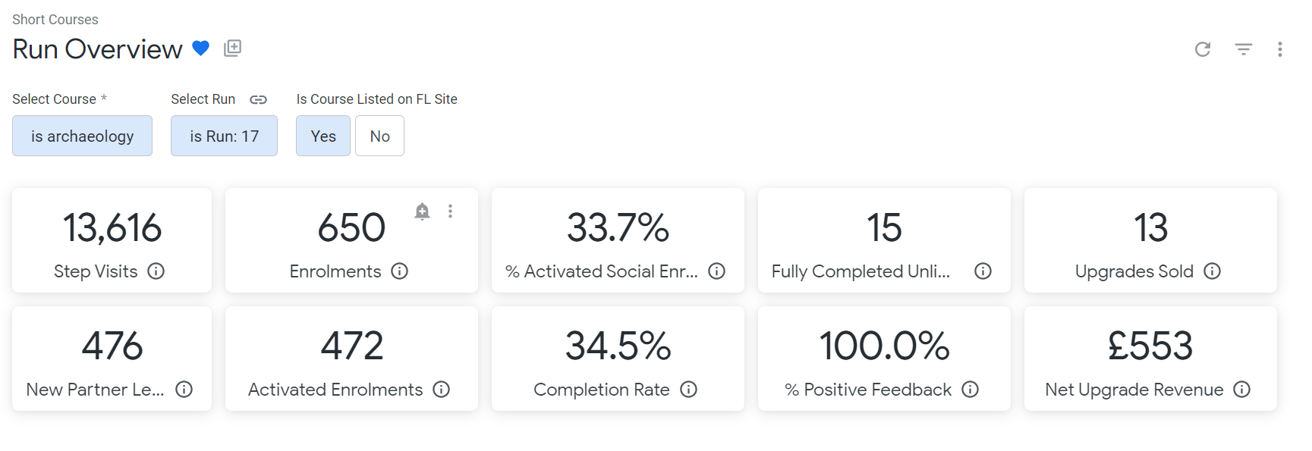
Depending on the areas you are focussing on in the Analysis sections, you can cross reference to these for discussions on, for example, completion rate and positive feedback.
Note: The FL average completion rate for short courses is 10-16%: 30% complete a paid course vs 8% for a free course (FL Conference, July 2022)

Analysis: Have the strategic objectives been met?
Look up the original strategic objectives for the course in the scoping document. List them and then deal with each one in a separate subsection: 2.1, 2.2, 2.3, etc. Objectives may be around global reach, completion rates, reaching a particular audience, etc.
Use measures from Platform or Looker as needed - make sure you note the source. And only include data relative to the strategic objectives as we’re trying to keep these reports short and focussed.
Note: We have asked FL for additional comparison data that we can use as benchmarks to measure our courses against.
If using the demographic data (learners by gender, employment and age), add a note that the FL platform doesn’t automatically collect data at this level of granularity. However, the pink bar charts are created from data provided via a FL optional learner survey and can give an idea of the types of learners on the course as long as we’re aware that they represent just a subset of the total learners and may be skewed towards particular groups therefore.
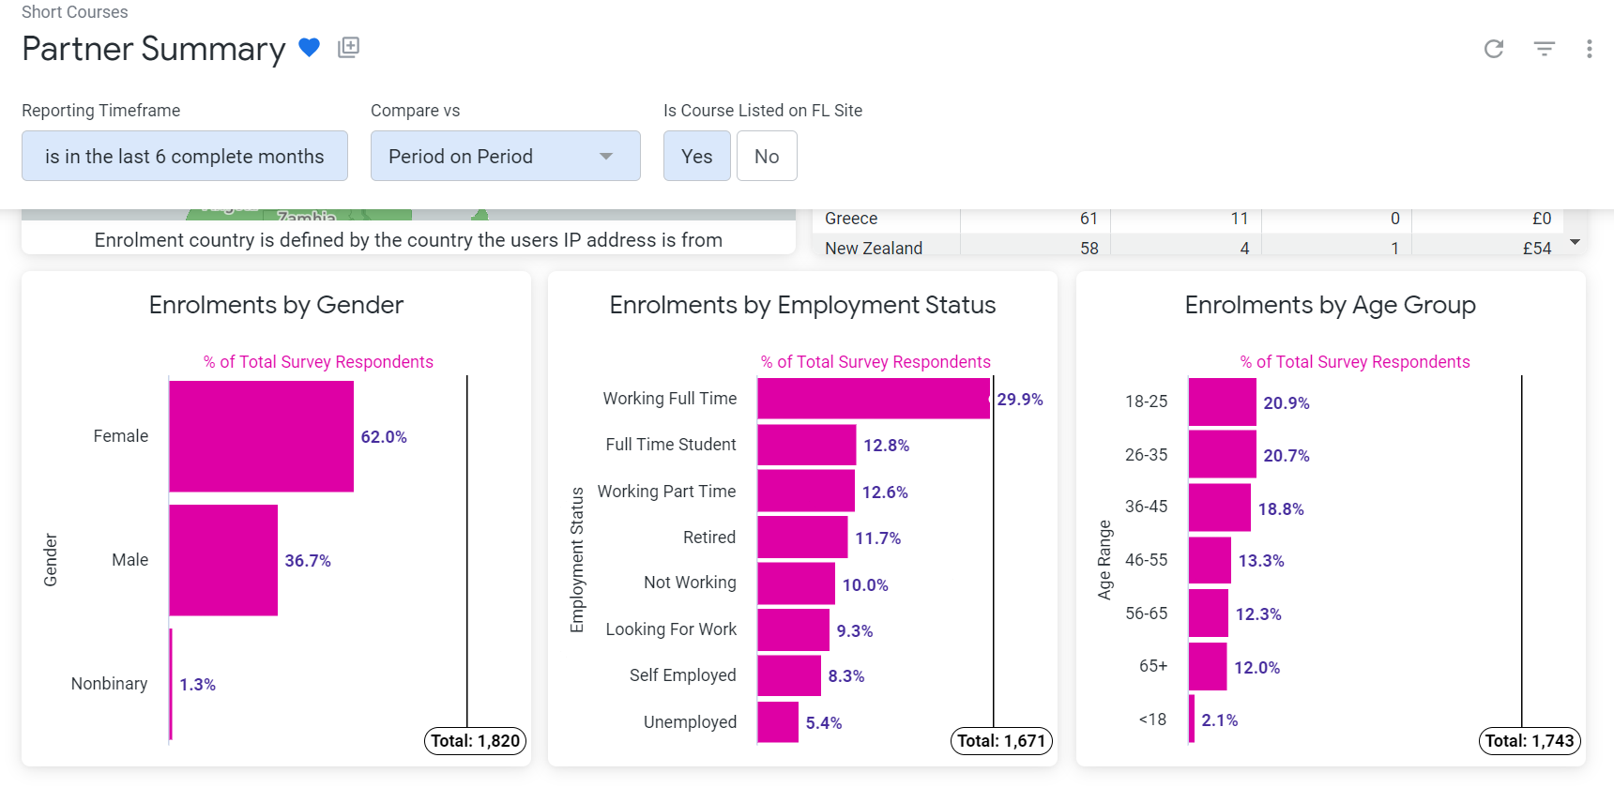
These can also be compared to the demographic data for the programme as a whole, if appropriate:
The following sources of information may also be useful:
- Course reviews
- End of course survey (both numbers and free text)
- In-course surveys (eg. pre- and post-course surveys) and polls if included
- Analytics from related marketing activities
- Lead generation tool
- Course log filled out by mentors to demonstrate impact measures (reach, reaction, learning and behaviour)

Cross-check to ensure it still meets the Short Online Courses strategic framework.

Analysis: Did we meet the content requirements? Are the learners happy?
Use the ABC Learning Design Framework as a reflective lens for critically considering the effectiveness of the various course components.
Using the yellow bar chart from the Run Overview on Looker, select 2 high activity and 2 low activity acquisition, discussion and investigate Steps from each Week (peaks and troughs in the red line).
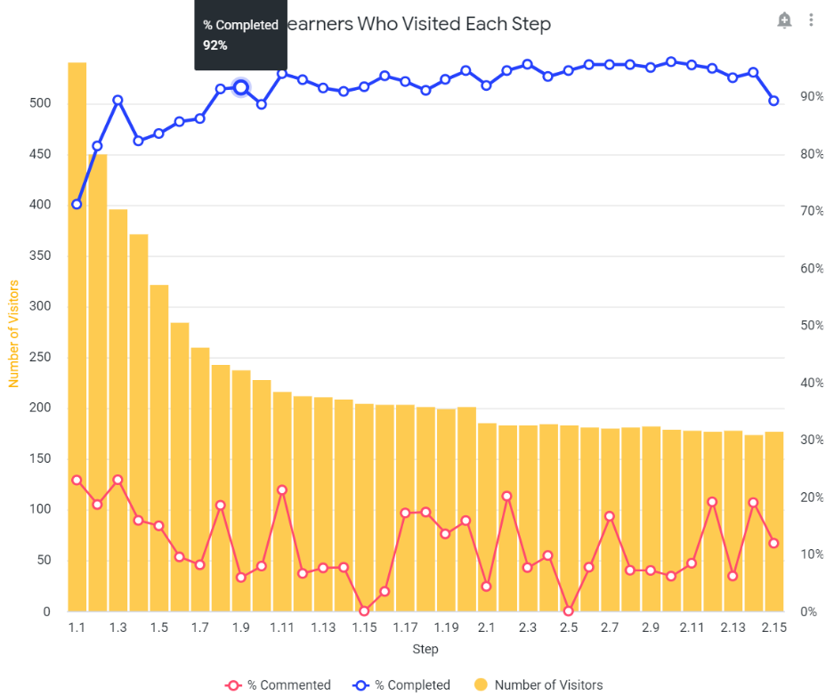

Copy the checklists and tables below into your evaluation report, mark them up and answer the questions for each chosen Step, reflecting on how they might be improved.

Acquire Steps
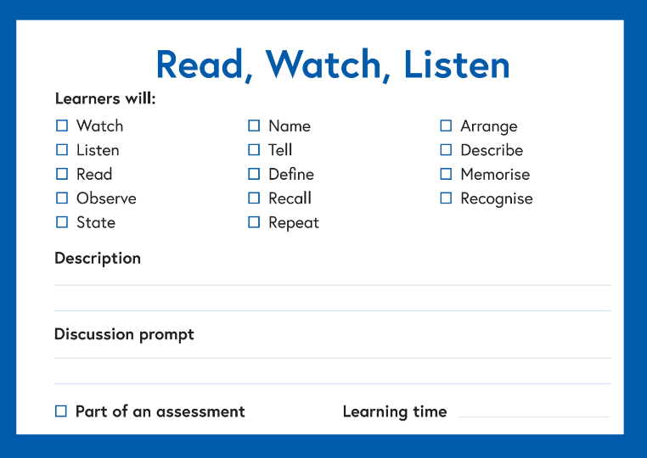
Step number and name | How effective were the reading, watching or listening materials you provided? | Did students find them useful and relevant? | Were they accessible and available to all learners? | Is there anything you would replace in the next course offering?
The following sources of information may be useful:
- Number and quality of comments
- Video viewing data (on the platform)
- Review by learners with accessibility requirements
Discuss steps (you can include any steps where a discussion prompt has been used)
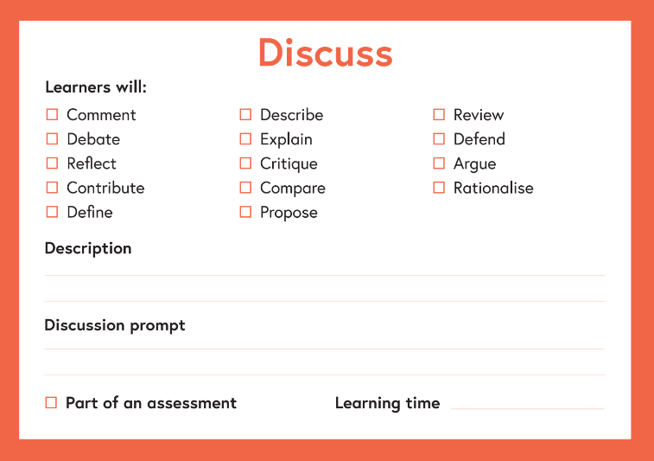
Step number and name | How effective was the discussion – did it prompt learner interaction? | What worked best in promoting rich discussion? | How useful were the discussion tool(s) or strategies you used? | How could you improve the level and quality of discussion in the next course offering?
And for the course overall: Were there enough opportunities for learner-to-learner dialogue or debate?
Practice steps
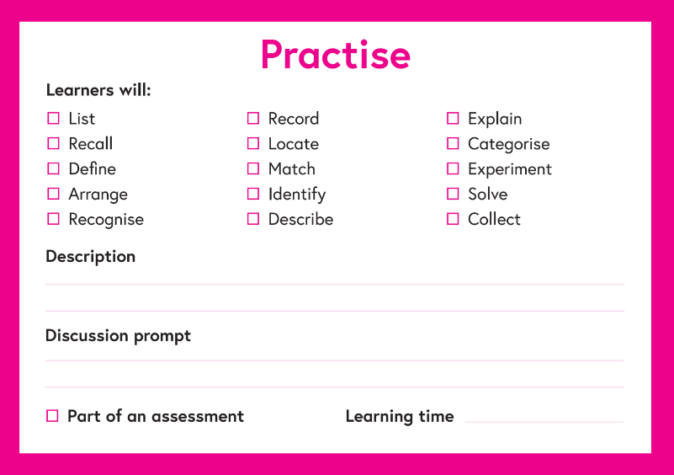
Step number and name | Were sufficient opportunities available for learners to practise tasks? | How effective were formative tasks in scaffolding learning? | How successful were students in applying their skills and knowledge in authentic settings or scenarios? | To what extent did the quizzes align with and help to meet the learning outcomes? | Is there anything you might do differently in the next course offering?
The following source of information may be useful for reflecting on quizzes as formative tasks:
- ‘Question response’ download from the Platform datasets

Investigate steps
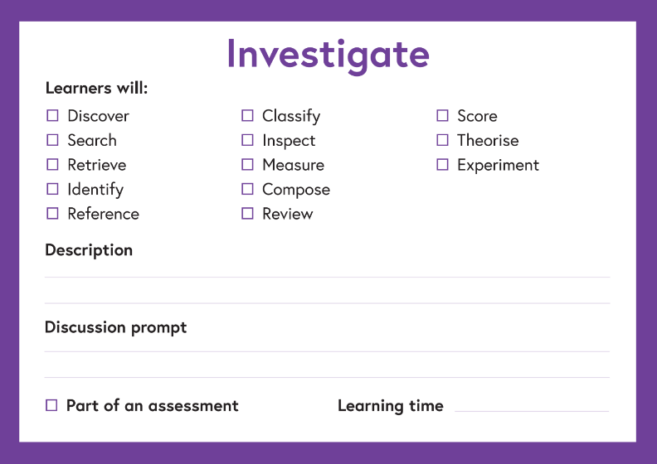
Step number and name | How successful was the course in engaging students to undertake their own investigative tasks? | How effective were investigative activities in supporting learning? | Did learners do what you expected/asked of them? | Did the learners enjoy this aspect of the course?

Produce step
Here, reflect on the final action you asked the learners to carry out – the end of course activity.
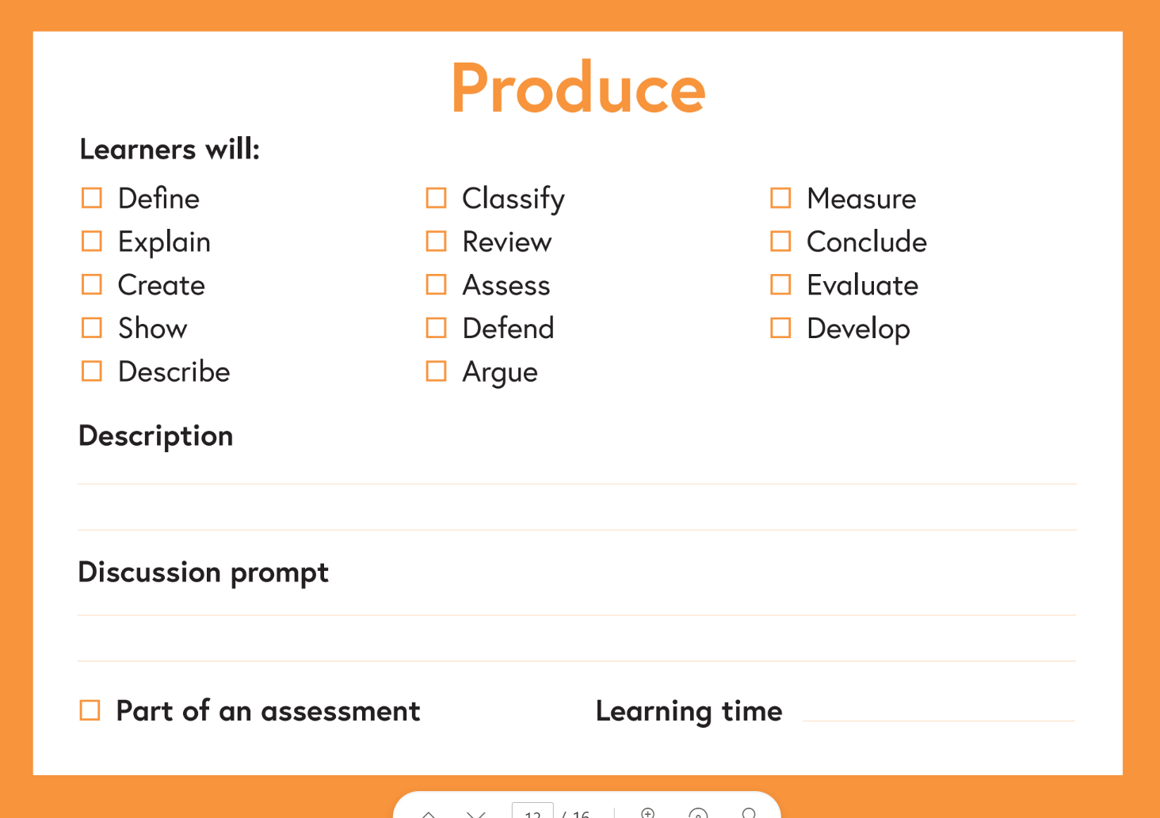

Step number and name | To what extent did this activity align with and help to meet the learning outcomes? | Did the quality of what learners produced meet your expectations? | Did learners do what you expected/asked of them? | Did the learners enjoy this aspect of the course?
If the course doesn’t include an end of course activity, consider adding one.

Note: The full evaluation tool is Reflecting with the ABC Learning Design Framework
Note: Feel free to omit questions if they’re irrelevant to the course. For example, younger learners don’t tend to engage in discussions requiring them to assert their opinions.

Finally, refer back to the learning outcomes. Have they been met? Yes or no? The following sources of information can help answer this question:
- Review star rating from the course description page – include the number of reviews as this affects the rating as they climb.
- Weekly sentiment response (Platform) and positive feedback percentage (Looker)
- Learner comments from the course log filled out by the mentor(s) – note that you can’t copy them verbatim but you can link to them.

Refinement
General recommendations can be incorporated throughout the report (Recommendation: blah blah blah) but this is the section to make specific suggestions about changes to individual Steps.

Step number | Step title | Suggested change | Actioned
Please keep a record of any changes made to the course in the ‘actioned’ column, including reasons for them and any decisions made.
The following sources of information may be useful:
- The yellow bar chart is good for identifying learner drop-off. Consider reasons.
- 1*-3* reviews can be quite helpful in pointing out areas that need addressing. Also, the free text in the end of course survey and Comments area in the last Step can hold constructive suggestions.
Important: When you do the updates, remember to incorporate the tasks on the new run checklist (Guides and processes > Update checklist for FP and Re-runs).

The evaluation process
Evaluations are completed for each course about 6 months after the launch date. This is more for the OC team than for the Educators, to check the learning goals have been achieved, refine the content and understand how well the target audience has interacted with it.
- Inform Educators that you’re about to carry out the evaluation (see template emails)
- Arrange an evaluation meeting to discuss the results and agree on any changes. At this meeting, agree on a date to launch the new run and inform Educators of their role in the evaluation process going forwards.
- If necessary, create new run and discuss with OC team and FL when to close the first one and open the new one.
- Depending on the number of changes made, there’s an option to perform a quick evaluation of the new run 6 months to a year later, comparing against the original report and refinements to see if they had any impact. (Copy the refinement table to this new report, adding a new column: Results) This is more for the OC team than for the Educators so judge the worth of this on a case by case basis.
- After that, every 2 years send an email to Educators asking if it’s still meeting strategic objectives, what needs to change, updates required. (Course review emails). (Incorporate this in business case form so they know their responsibilities and can commit to reviewing every 2 years.)

Note: There are some exceptions to the 2 year rule, eg. Study UK needs a full evaluation every run.

- When you get the response from the Educator, fill in the table at the bottom of the email recording actions taken and reasons for them. Download the email thread, rename it ‘Educator review_date’ and file it in the Evaluation folder of the relevant project.

