What’s driving non-continuation? Learnings from the APP ‘calling campaigns’ activity (blog)
Mathew Haine, Student Outcomes Manager
Our Access and Participation Plan includes an activity called ‘calling campaigns’. The original idea was that interviewing former students from our continuation target groups (Black ethnicity, mature age) who had failed to continue would offer first-hand insights from the students affected by non-continuation.
This would tackle the shortcoming many institutions face: student voice schemes tend to attract ‘engaged’ and academically high-achieving students who ultimately can’t speak to the experience of peers who fail to continue. It is those students we must learn from.
In theory, these calls could bring to light previously unknown barriers and help us prioritise broad areas of focus. In practice, we went as far as producing interview scripts, surveys and evaluation plans before losing confidence in the activity as originally conceived.
I am a “non-continuer” myself. I first went to Keele University in 2008, where my personal circumstances dictated that I first failed, re-enrolled, then withdrew from, my first year of study. It was only years later, as a mature student, that I progressed (and graduated with a ‘good degree’) at the University of Surrey. Today, this rollercoaster experience of higher education is what motivates me professionally. But it also gives me some personal insight into how messy and tender the reality of “non-continuation” can be.
That is to say: non-continuation is a significant life event. We simply can’t be sure it is ethical to ask people moving on with their lives to relive potentially sensitive experiences over the phone or by survey. That is assuming people would respond in significant enough rates at all.
Fortunately, the insights gathered from the data alone offer us useful starting points.
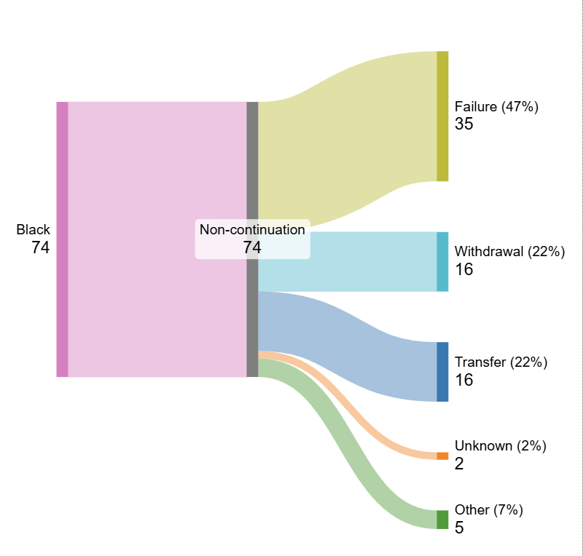
Academic failure is driving the Black-white non-continuation gap
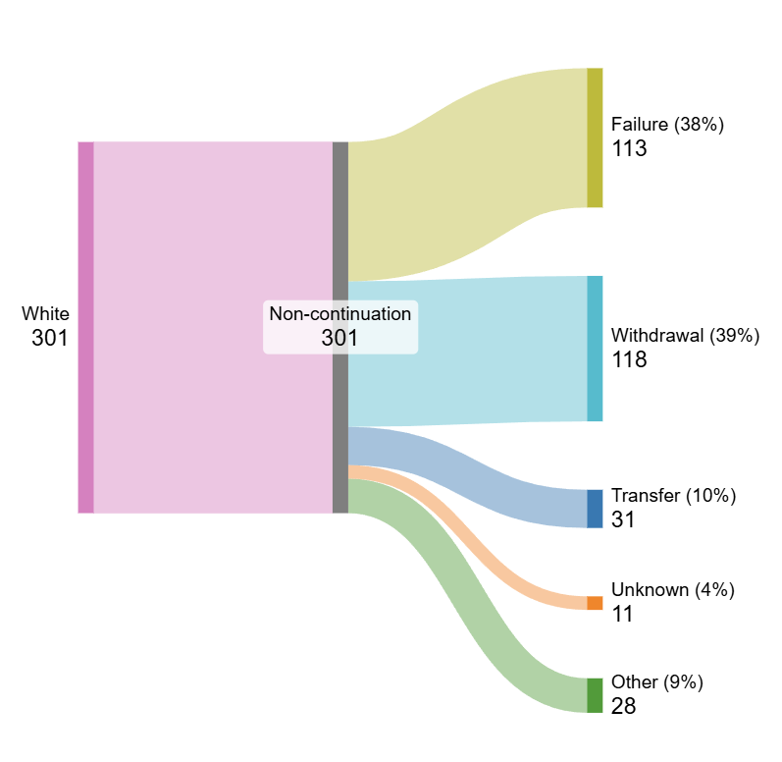
A lower proportion of our Black ethnicity students are opting to withdraw (-17%), and a higher proportion are failing to continue due to underperformance in assessments (+9%).
This confirms the idea that a disproportionate chunk of this APP target group is trying to continue and not succeeding, meaning inequalities in our curriculum and our assessment practices could account for a substantial portion of the continuation gap.
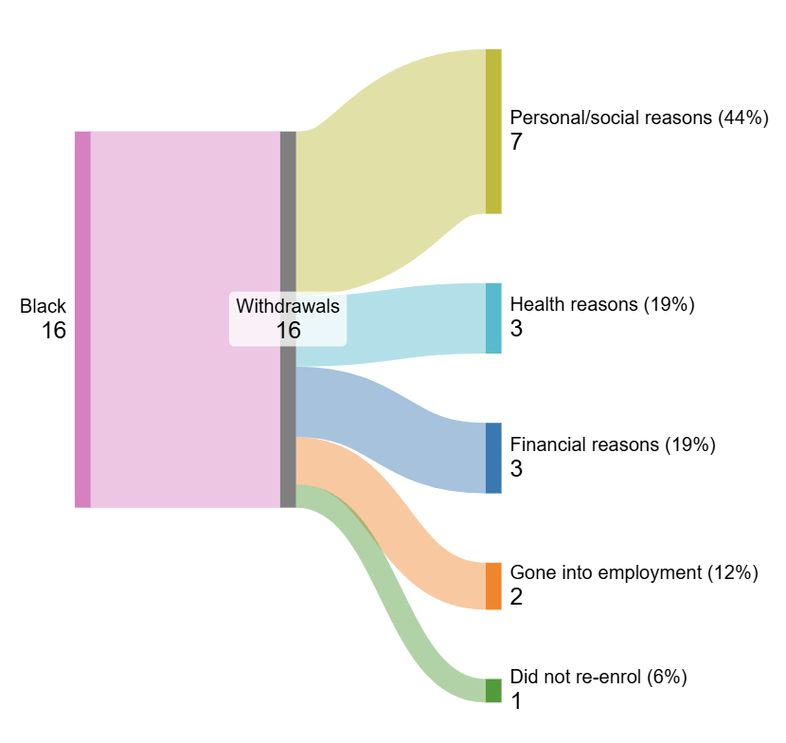

Within the voluntary withdrawal group, more of our Black students were leaving for unspecified personal reasons, as opposed to reasons like entering employment (-5%) or health concerns (-11%). Of course, we only know what students tell us on their withdrawal form and ‘personal reasons’ could cover a range of experiences.
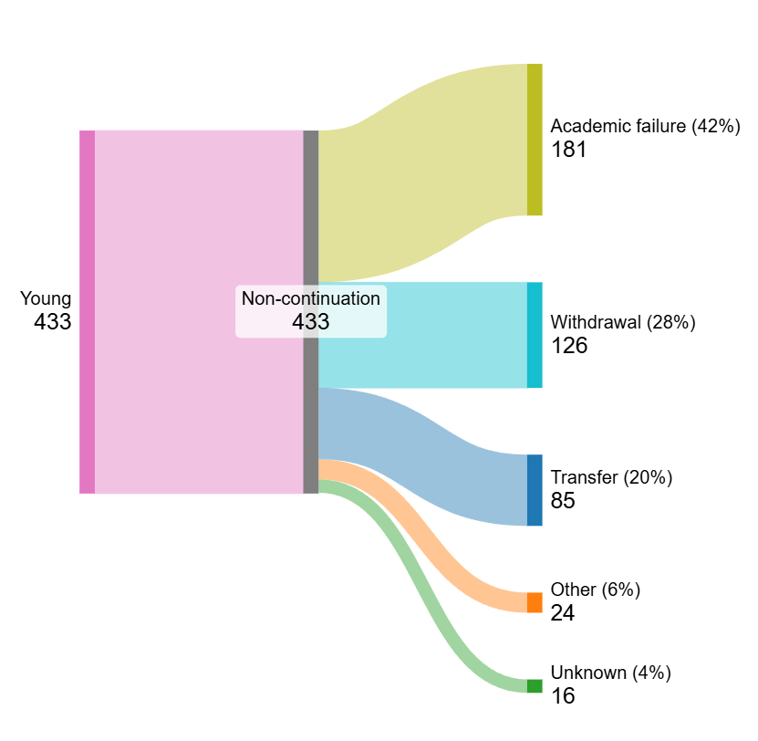
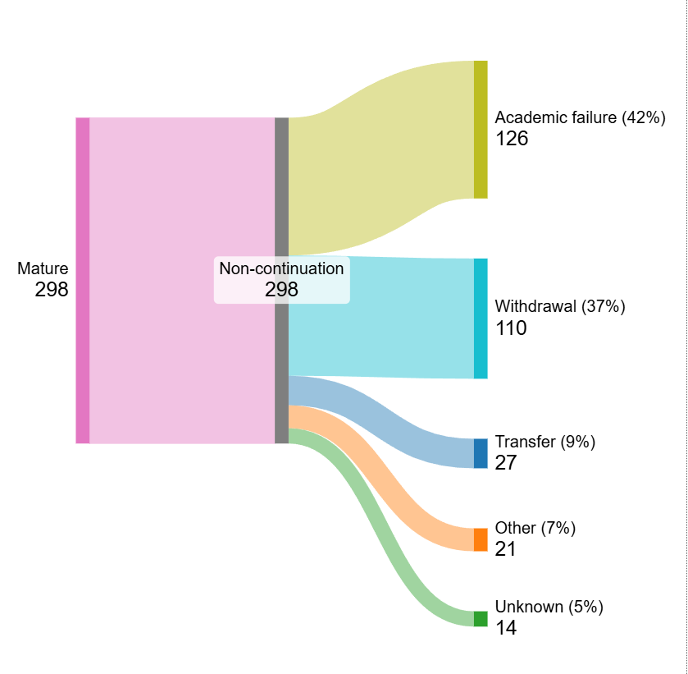
Voluntary withdrawal is driving the age non-continuation gap

When comparing mature and young learners, perhaps surprisingly, the rates of academic failure are the same (42%). The difference is that more mature students are voluntarily leaving UoR through withdrawal (+9%).
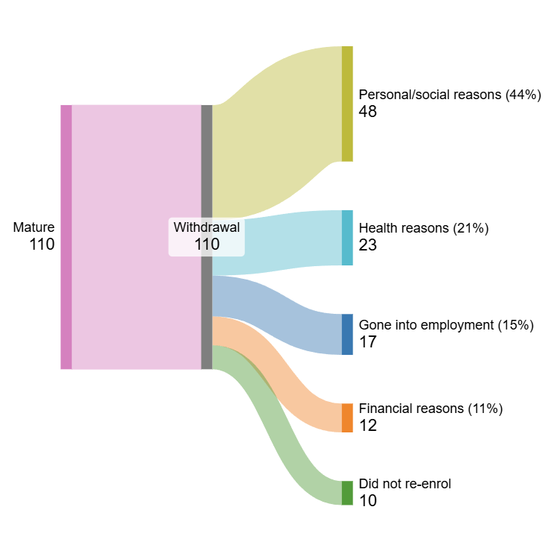

Looking further shows that these students are leaving HE altogether. Personal reasons account for 11% more withdrawals in the mature group, and a lower proportion was entering into employment (-10%) or transferring to another provider (-11%).
Perhaps it’s safe to speculate that mature students - who often manage personal responsibilities such as dependents and homes – are just more likely to decide that HE is not right for them. This poses the interesting question of whether it is the responsibility of institutions to dissuade target students for the sake of continuation rates.
In either case, monitoring these reasons for non-continuation on an ongoing basis should give us the institutional knowledge we were seeking in the first instance. The work of our Success Partners on the Home Foundation Year, testing a model of early intervention for disengaging students, should help to ‘catch’ potential non-continuers before it’s too late.
Alongside all of this, we are still passionately focused on developing healthy curricula and academic success for all students, so those who wish to continue have the best opportunity to do so.

See the blog here: https://blogs.reading.ac.uk/app-evaluation-blog/2026/09/09/whats-driving-non-continuation-learnings-from-the-app-calling-campaigns-activity/

